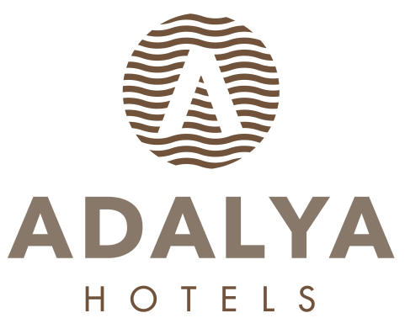
HOTEL FACT SHEET

- GENERAL INFORMATIONS:

HOTEL NAME : ADALYA RESORT & SPA HOTEL
LOCATION : EVRENSEKİ TURİZM MERKEZİ
KATEGORIE : 5 (FIVE) STARS HOTEL
ADRESSE : EVRENSEKİ / MANAVGAT / ANTALYA
TELEPHON : + 90 242 763 05 60 pbx
FAKS : + 90 242 763 04 16
WEB PAGE : www.adalyahotels.com

E-MAIL : info@adalyaresort.com

- HOTEL TRANSPORTATION:
TO DISTANCE METHOD DURATION
SİDE CITY CENTER 10 km Shuttlebus / Taxi (+/-) 20 Min.
MANAVGAT CITY CENTER 12 km Shuttlebus / Taxi (+/-) 20 Min.

ANTALYA AIRPORT 65 km Taxi (+/-) 55 Min.

- ACCOMODATION:

TOTAL ROOM : 210 ALL ROOMS ARE WITH:
TOTAL BED : 460 Telephone
Hot Drinks Set-Up
Standard Double Rooms : 165 (+/- 30m²) (1- French Bed + 1-twinbed) LCD TV (Satellite)
Standard Double Rooms : 23 (+/- 30m²) (1- French bed or 2-twinbed) Mini bar
Standard Family Rooms : 20 (+/- 55m²) (1- French bed + 1-twinbed) Safe Box
Handicap Friendly Rooms : 2 (+/- 30m²) (1- French bed + 1-twinbed) Balcony

- SPECIAL FEATURES:

Site Surface : 13.000 m² OPENING TIMES:
Outdoor Pool (open) : 480 m² 07: 00 / 20: 00
Children Pool (open) : 20 m² 07: 00 / 20: 00
Indoor Pool : 80 m² WITH HEATING SYSTEM 08: 00 / 19: 00
Relax Pool (open) : 153 m² 07: 00 / 20: 00
Aqua Park (open) : 96 m² 3 Slides

Main Restaurant : 882 m² Indoor (+/-) 300 Person – Outdoor (+/-) 150 Person OPENING TIMES:
Ottoman A’la Carte Restaurant : 120 m² (+/-) 55 Person 19: 00 / 21: 00
Patesseria : 72 m² (+/-) 30 Person 11: 00 / 22: 00
Lobby Bar : 195 m² (+/-) 250 Person (Außen) (+/-) 150 Personen teras 10: 00 / 24: 00
Pool bar : 165 m² (+/-) 100 Person 10: 00 / 24: 00
Beach Bar : 208 m² (+/-) 150 Person 10: 00 / 18: 00
The Bigos Bar : 65 m² (+/-) 50 Person 24 Hours
Disco Bar : 144 m² (+/-) 100 Person 24: 00 / 03: 00
Game Hall : Billiards, Chess, Air hokey, Table soccer, Video games and Bowling (Extra charged)
Wellness, Beauty Center / SPA : 600 m² Turkish Bath, Sauna, Special massages, SPA, VİP Massages, Steam Room,
Mini club : For children between 4 -12 ages
Shopping Center : Jeweler shop, Market, Hair Dresser, Boutique, Leather shop, Silver Shop, Souvenier, Photo shop, Bag Shop.
Fergano Meeting Hall : 630 m² (+/-) 400 Person
Meeting Room : 75 m² (+/-) 50 Person
Cleaning Services : Daily Room cleaning and Towel change available.
Beach : 100 meter long, Sand & Pebble mixed has Blue Flag Certification, it is a private beach

- SPORT, FUN, HEALTH & BEAUTY SERVICES:

Extra Charged Free of Charge
* Billiard * Daily Activities (Special Games)
* Internet cafe and video games * Animation Shows
* Massage & Peeling – Foam, * Fitness Center
* Skin Care * Special Gala Party, 1 time in every 2 weeks
* Hair Dresser * Turkish bath, Sauna,
* Beauty center * Table Tennis, Dart, Beach Volley, Boccia
* Water Sports in Beach (Parachute, Boat, Cano, Wind Surf * Step, Aerobic, Gymnastics, Water Gym
* Mini Club between 4–12 old kids, Mini disco

- GUESTSERVICES :

Extra Charged Free of Charge

* Doctor * Animation Show
* Jeep, car rental, Bicycle and baby care rental * Mini Library
* Shopping center * Wireless in Hotel
* Airport Transfer * Mattress and Umbrellas at the Beach and Pool
* Laundry * Beach Towel
* Baby Care
* Telephone and fax
* Room Services
* Wireless in Room
* Safe Box in Room

- USEFULL INFORMATIONS:

*** Use full Credit Cards : Visa, Master card, maestro card,
*** Languages : Turkish is the official language. German, English and Russian are spoken
*** PETS ARE NOT ALLOWED.

