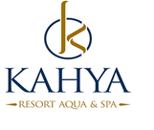

2019 SUMMER FACT SHEET & CONSEPT

Hotel Name : KAHYA RESORT AQUA & SPA
Category of the hotel : 5 Star
Address : Payallar Mah.Öztürkler cad.No:3 Alanya / ANTALYA
Telephone : 00 90 242 545 35 35
Fax : 00 90 242 545 40 33
Web Site : www.kahyaresorthotel.com
E-mail : info@kahyaresort.com
Year Built : 2012
Renovation date : 2015
Number of Rooms : 447
Number of Beds : 1200
Hotel Area : 36000 m²
Pension (Board) : All Inclusive

Location
Airport : 110 km
City Center : Konaklı City Centre 2 km
Next Town : Alanya 16 km
Hospital : 2 km
Transportation : Bus - Taxi - Minibus

Others
Credit Cards : Visa, Master
Pets : Not accepted
Voltage : 220

Rooms – Equipments
Total Number of Rooms : 447
Standart Room : 279 (34 m2 1 Single and 1 Doublebed, 1 sofabed)
Family Room : 144 (36 m2, 2 Rooms with connecting door, 2 Singlebed and 1 Doublebed)
Junior Suit : 21 (52 m2, 2 Rooms with connecting door, 2 Singlebed and 1 Doublebed, Sofabed for 2 Person, 2 Bathrooms)
Suit : 3 (65 m2, 3 Rooms with connecting door, 2 Singlebed and 1 Doublebed, 1 Livingroom, 2 Bathrooms)
Handicapped Room : 5 (3 Standartrooms / 1 Family Room /1 Jjunior.Suit )

Floor Covering : Laminate
Balcony : ✓
Bath Type : Shower
Air Condition : VRF-central
Hair Dryer : ✓
Telephone : ✓
Minibar : ✓ (The minibar will filled only at the arrival with water and mineralwater)
Safe Box : ✓ (extra charge)
Satelite : ✓
Musıc : Tv musıc channel
Room Cleaning Periods : Daily
Specify Periods of Changing
Bed Sheets/Towels : They will be change every two days.
Beach Towels : ✓

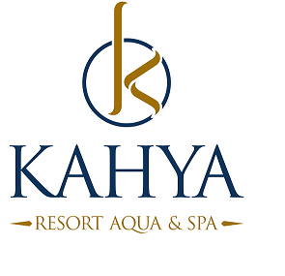

POOLS
2 Outdoor pool - 960 m2 -160 m2
Pool with slides ( 5 slides ) 120 m2
A children's pool, -95 m2
Pool River -580 m2
Space bowl-24 m2
(All pool and water slides are used according to the weather condition.)

Food & Beverage
Breakfast : 07:00 – 10:00 Main Restaurant Open Buffet
Late Breakfast : 10:00 – 10:30 Main Restaurant Open Buffet (limited)
Lunch : 12:30 – 14:00 Main Restaurant Open Buffet
Dinner : 19:00 – 21:00 Main Restaurant Open Buffet
Midnightsnack : 22:00 - 06:00 Patisserie

Bars
Lobby Bar : 10:00-24:00 (Local alcoholic drinks,hot and soft drinks)
Relax Bar : 10:00 -18:00 hot ,soft drinks
:18:00-24:00 Local alcoholic drinks, hot and soft drinks

Aqua Bar : 10:00 – 20:00 (Beer,Wine,hot and soft drinks)

: 20:00 – 24:00 (Local alcoholic drinks,hot and soft drinks)

Snack Bar : 10:00 -17:30 (Beer,Wine,hot and soft drinks)

Snack: 11:30-16:00
Coffee &Cake : 16:30 – 17:30

Bistro Pub Bar : 16:00-19:00 hot ,soft drinks
: 19:00-00:00 Local alcoholic drinks,hot and soft drinks

Beach Bar : 10:00 - 17:30 (Beer,hot and soft drinks)

Snack (11:30-16:00)

Patisserie : 14:00 – 24:00 (cakes,hot and soft drinks)

Disco Bar : 24:00-03:00 (All the drinks with charge)

Beach

Access : 50 m.way through an underpass
Beach condition : sand / gravel
Seabed: : sand and rocks

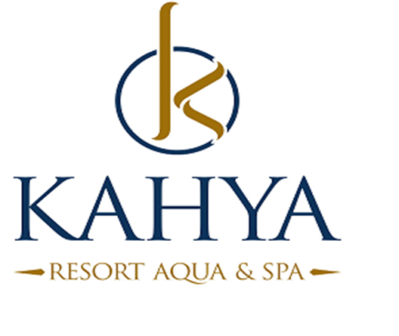

Entertainments

Daily Activities : Sport activities, pool games, music
Night Program : Show-time /the evening program
Kids Animation : Mini club activities (4-12 years-certain hours- 6 days a week)
(Entertainments 6 days a week)

CHARGEABLE AND FREE SERVICE
ACTIVITIES | DETAILS | EXTRA | FREE
Restaurants | Breakfast, lunch, dinner |  | x
Local drinks | All inclusive times |  | x
Import drinks |  | x
Fresh fruit juice |  | x
Room service |  | x
Safe box | In the room per day 2 € | x
Wireless | Only Lobby |  | x
Doctor service |  | x
Ice cream | (3 days a week and certain hours) |  | x
Minibar | The minibar will filled only at check-in with water and mineralwater. |  | x
Hamam |  |  | x
Sauna |  | X
Massage |  | x
A la Carte; Ottoman / Fish | One accomodation staying there you will use A la Carte 1 order free./ with Reservation-by availability. A la Carte Restaurant is alternately open certain days of the week. |  | x
Fitness | 08:30-18:30(not allowed under 16 years) |  | x
Baby Bed and Chair |  |  | x
Water Slides / Aqua | 5 (certain hours) |  | x
Table Tennis | with Reservation-by availability |  | x
Disco | 24:00 till 03:00 |  | x
Disco | All drinks | X
Patisserie / Tv Room |  |  | x
Umbrella and Sunbeds | Pool and Beach |  | x

Turkish Coffe |  | x
Laundry service |  | x
Late c/out | by availability | X
Flowers and Cake | Reservation by Guest Relation | x
Main Restaurant Capasite | inside 350 outside 500 pax |  | x
Meeting room Capasite | Max.300 pax |  | x

All activities can vary depending on the season and the weather.
Service hours are on the hotel’s own savings.
Paid activities fees may variable by hotel.

