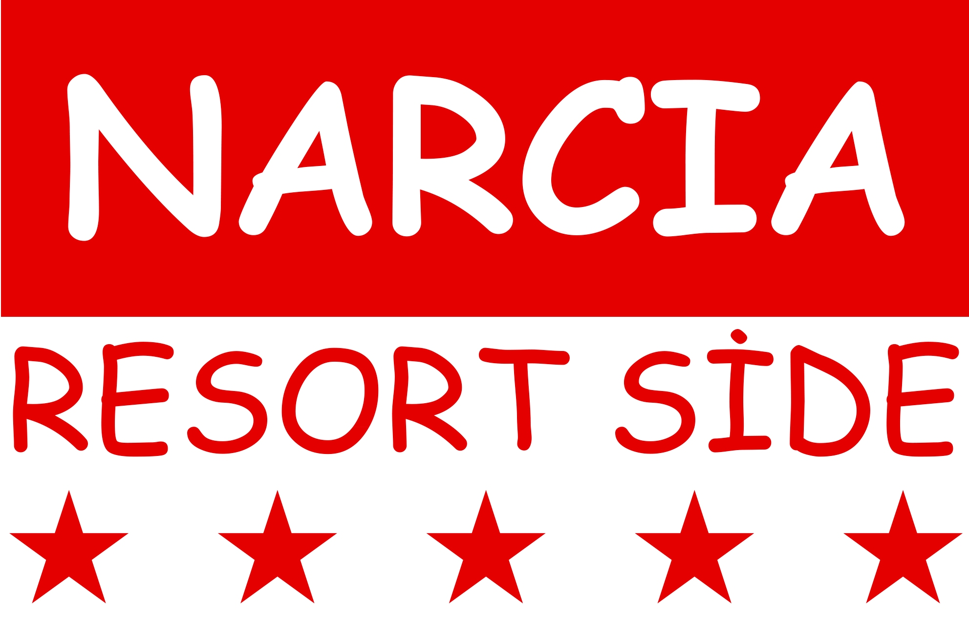

Ilıca Beldesi Ilıca Mh. 24. Sk. No:8
Side-Antalya-Türkiye 07330
Tel. : 00 90 242- 756 07 00
Fax : 00 90 242- 756 07 01
Web : www.narciahotels.com
e-mail :info@narciahotels.com

Narcia Resort Hotel Side
Official category : 5 Stars

Location:
NARCIA RESORT HOTEL SİDE is located in the center of Kumköy/Side, which is the most famous tourism center of Turkey. Nearby our hotel there are shopping centers, restaurants, bars and night clubs. Our hotel is 5 km far to Side, 8 km to Manavgat, about 55 km to Antalya Airport and 65 km to the center of Antalya. The distance to the international Golf places in Belek is 40 minutes.The sandy beach is 350 mt far to our Hotel. A shuttle service is available.

Rooms:
Our hotel consists of 1 main building, 1 Club Building and 2 annex buildings, totally 4 buildings in the hotel area. The main building has 6 floors and 4 elevators. Club Building has 4 floors and one elevator.2 annex buildings each has 3 floors and 1 elevator. The main building consists of 228 standard rooms and 3 rooms for disabled. The annex buildings consists of 62 standard rooms. Club building consist of 61 rooms. Our hotel has totally 351 rooms and 800 bed capacity.

Main Building Standard Rooms: Standart rooms are 27.3 m² (except balcony) .Maximum occupancy for 2 adults + 2 children or 3 adults + 1 child. The rooms are comfortable and modern decorated. All our rooms have individual airconditioning, safe box, hairdryer, WC, shower, balcony, wooden floor, Kettle and tea coffee making facilities, mini refrigerator and Sat-LCD-TV

Main Building Rooms for disabled : The rooms are furnished and decorated like the Standard rooms just without treshold and are specialised for disabled people and wheelchair-drivers. The doors and the bathrooms are much bigger than the standard rooms. The bathrooms can be used easily for disabled people.

Annex Building Eco/low cost Rooms - Completely renewed in 2020: Eco rooms are existing in annex buildings and are 21,0 m² (except balcony).
Maximum occupancy for 2 adults +1 children or 3 adults . These rooms are same as standard rooms but with a smaller bathroom.

Club Building Family Rooms (Built in 2019) : Club Family rooms are 31 m2 (except balcony) and has two sleeping rooms.One of the room has 1 big bed and other has 2 single beds. Minimum occupancy 3 for adults, Maximum occupancy for 4 adults. The rooms are comfortable and modern decorated. All our rooms have individual airconditioning, safe box, hairdryer, WC, sprinkler shower, balcony, wooden floor, Kettle and tea coffee making facilities, mini refrigerator and Sat-LCD-TV. The passage is provided by a 37-meter tunnel from the main building.

Club Building Standart Rooms (Built in 2019) : Club standart rooms are 25 m2 (except balcony) . Has 1 big bed and 1 single bed.Maximum occupancy for 3 adults. The rooms are comfortable and modern decorated. All our rooms have individual airconditioning, safe box, hairdryer, WC, sprinkler shower, balcony, wooden floor, Kettle and tea coffee making facilities, mini refrigerator and Sat-LCD-TV. The passage is provided by a 37-meter tunnel from the main building.

Food and Beverages: Ultra All inclusive: Breakfast, late breakfast, lunch, dinner as open buffets, late night buffet, tea/coffee & cakes, snacks, Stone oven flatbread, turkish pitta (gözleme), local alcoholic, some imported spirits and soft drinks, ice cream.
Fresh squized fruit juices, packaged ice cream and imported drinks are by charge.

Nar Retaurant - Main Restaurant: Max capacity 680 pax (indoor and air-conditioned restaurant is for 400 pax and terrace restaurant is for 280 pax).

A’la Carte Restaurants: We have 2 A’la Carte Restaurants. Ottoman & Fish A’la carte restaurant. This can be booked once per stay free of charge.

Patisserie: Coffee, Tea & Cakes.

Bars: Lobby bar by 24 hours service(free), Pool bar, Snack Bar, Disco, Beach Bar, Animation Bar and Aqua Bar. Our bars can be used between 10:00-24:00 free of charge.

Pools: There is 5 swimming pools in our hotel.1 main pool (570 m2), 1 relax pool (132 m2) , 2 aqua pool (slide pool is 520 m2 30 cm height, the other one is 90m2 140 cm height ), 1 indoor pool (75 m2, 12.04.2019-31.05.2019, 01.10.2019-31.10.2019)
*In every pool area is also a children pool included.

Aquapark : There is seven water slides 2 of them located at the mainpool area and one slide at the children’s pool. Other 4 modern water slides are located at the club building area.

Sport & Entertainment: Our entertainment team is day and night there for our guests. At the pool bar and at the animation stage, there are several special evening shows. We have also library, fitness room, table tennis, darts, backgammon and card games, hamam and sauna
Mini Club: Children between 04 and 12 years, we offer a playground and a kids club. Our animation team offers special games and shows for our kids.
Meeting Rooms: We have 1 Meeting Room for 350 pax.
Services By Charge: Safe boxes in the rooms, massage, doctor, photograph, hair dresser, mini market, leather shop, boutique and other shops, water sports (offered by local firms at the beach) and coin operated gaming machines.

Free of Charge Services: Turkish bath (hamam), sauna, steam bath, sunbeds, umbrellas and matresses at the pool and at the beach, table tennis, Wi-Fi (lobby) and soft play area in the Game Room.

Other Services: Mastercard,Eurocard and Visa are accepted. Pets are not allowed.

ALL ABOVE MENTIONED ACTIVITIES, OPENING TIMES AND DAYS CAN BE CHANGED ACCORDING TO THE SEASONAL AND WEATHER CONDITIONS.

