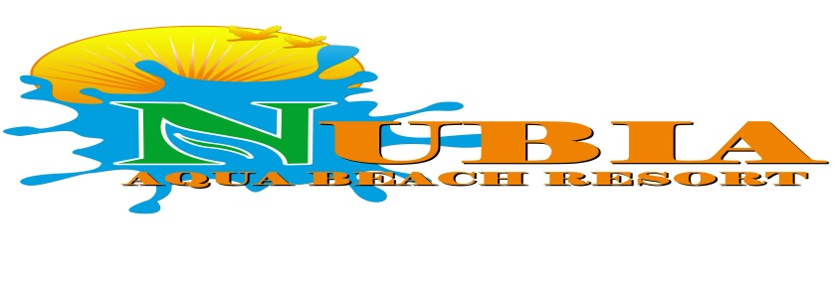

Address: Kilo 13 El Gouna Road- Hurghada Red Sea District- Arab Republic of Egypt
Hotel Category: 5 stars
Telephone :( +2) 065 9201750 - (+2) 065 9201751
Facsimile: (+2) 065 3445225
Web page: www.nubia-resort.com
E-Mail: info@nubia-resort.com

Location located directly on the Beach (sandy Beach)
11 kilometers from downtown - 17 kilometers from airport

Rooms: 456 deluxe rooms & Suites with lavish landscape, the property is built on 63500 sq. meters
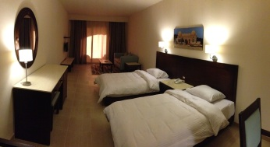
All rooms are equipped with 32 inch LED satellite TV (64 channels)
Air conditioning, bath tub or shower cabin, Toilet, telephone, hair dryer, mini bar, safe
Deposit box, laundry & valet service and 24 hour's room service

Swimming pools: four outdoor swimming pools & one Jacuzzi with fresh water, encompassing 551 sq. meters (heated) during winter & 451sq.meter & 429 sq. meter Separate children pool 176 sq. meters
Aqua Park with 3 slides

Hotel Beach Total beach area is 15000 sq. meters uniquely designed

Health Club Located in a separate building adjacent to the swimming pools area, designed to meet your daily workout requirements, with fully qualified and certified fitness instructors.
Our Spa has Sauna, 2 Steam bath, 2 Jacuzzi, 8 message rooms, and Turkish bath
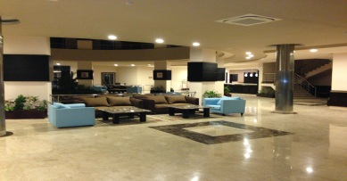
Kids club & playground fully equipped kids club & playground area, NUBIA resort offers varied attractions to our junior clientele designed to make your child's vacations as memorable as your very own.
Our caring team of international animation provides creative and educational
Entertainment, arts, crafts, and water sports, beach games, located adjacent to swimming pools area.

Sports & activities Beach volley ball, chess water sports aqua center & kite center
Animation international Animation Team for adults & children, performing several day activities and evening shows.

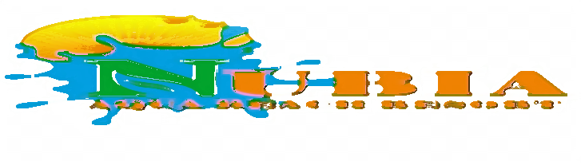
Restaurants & Bars

Panorama restaurant: serving breakfast, lunch & Dinner buffet, located in the main building on the Second floor
BBQ restaurant: outdoor, serving Light Lunch (BBQ Items & Pizza)

Beach corner: outdoor, Serving Light Lunch

4 Ala carte restaurants: Lebanese, Russian & Italian corners inside the main building, in addition to Chinese located at the hotel façade.
Bars: Lobby bar, terrace, plus three pool bars.
Teatro bar Shisha corner with DJ & live entertainment, located at the hotel entrance area.
Discotheque located at the main building
Room service: operating 24 hours

Conference Hall: meeting & Banquet rooms, 500 Sq. meters with an outside entrance and another entrance from the lobby.

Amphitheater: Open air for the daily animation & entertainment show.

Doctor in addition to our clinic, the hotel doctor is available 24 hours

Transportation twice per day a shuttle bus to downtown & limousine modern cars

Shopping Arcade includes a wide variety of shops that covers all your needs including a Pharmacy

Internet: internet café is available at the lobby in addition to WIFI that covers the entire resort.

