

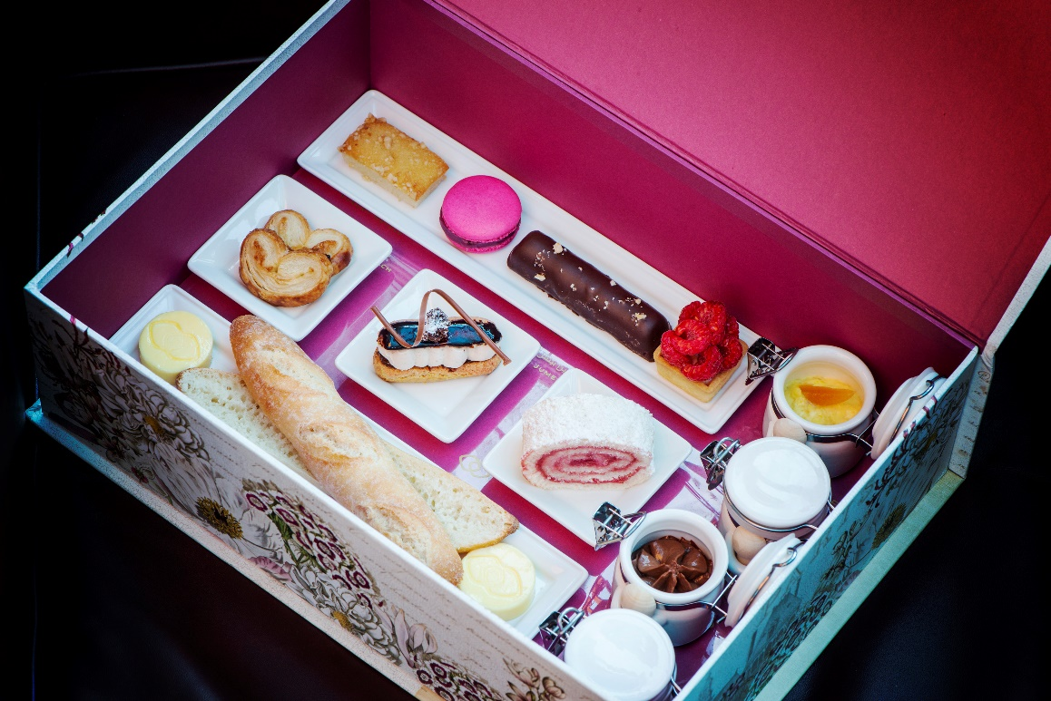

Le Goûter, a must-try classic French afternoon treat where you can indulge in freshly baked French baguette, homemade hazelnut spread, chocolate bar, saffron infused rice pudding with our signature date éclair, macarons and madeleines with your favourite cup of coffee or hot chocolate.

Timings:
- Daily 3.00 pm to 5.00 pm

Price:
- AED 69 per person

Webpage: https://www.sofitel-dubai-jumeirahbeach.com/offers/le-gouter/
Call: +971 4 448 4733
Email: dining.JBRdubai@sofitel.com

