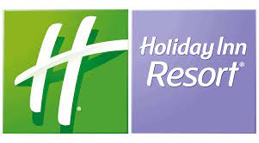

**We are renewing for our guests**

**Dear valuable partners,**

As we are preparing to host our guests, would like to present our new concept and services

**Our location:**

Holiday Inn Resort Bodrum is located the gently sloping hills on its private cost. Hotel is looking to Bodrum port and tower and with its own longest private immaculate Aegean Sea.

Our renewed hotel is 34 km to the Bodrum International airport and 1.8 km to the centre and Bodrum Port

**Front Office:**

Our hotel has been renovated and equipped according to the newest modern hospitality standards. Individually or as group, during their arrivals will have fast check in & check out opportunities.

**Internet:**

Our highspeed internet infrastructure has been redesign and build for our guest comfortability in highest standard. Our guest will be using as indoor & outdoor very comfortably

**Elevators:**

For our guest comfortability we designed and replanned all elevators. From lobby lounge till the sea side they will connect comfortably.

**Our Team:**

Our experience team members will performance their best for our valuable guest. All our chefs, maids, waitress, barman with technical team we are going to show all their talents for our guests.

**Rooms:**

Our hotel has 266 unite rooms. All our guest room facilities and amenities such as; a shower room. A hair dryer, a mini bar, a coffee and tea maker, a cable tv an IDD telephone, a safety box and a fully powerful complimentary in-room WI-FI

Our guest rooms as furniture, IT – IP and highspeed internet system has been up great. Our highspeed internet will be able in all our rooms and all hotel areas including elevators too.

Our beach side terrace suites also have been totally renovated and donated with tea – coffee and espresso machines.

Our guests if they wish on their room will enjoy their worlds TV channels with their IP TV.

**Food & Beverages Facilities:**

During their vacations our guest will have chance to taste our delicious cultural concept nights, ala carte outlets as regional and worldwide unique enjoyments with several outlets

Our talented kitchen and service team will prepare cook their best national and international enjoyments for our guests. Our bars will present different type of beverages, cocktail and large sprits at the all part of the hotels.

**Food & Beverage Served Areas:**

* Lobby Lounge
* Bars
* Patisserie
* Centre Restaurant
* Pool Café & Bar
* Snack Bistro
* Taksim Kiosk
* Sea Food Restaurant
* Italian Restaurant

**Lobby Lounge:**

Robust and rich blend coffees, blended tea dishes, snaps, liqueurs, brandy, 12 years premium whiskies, choice of wines, salted and sweet cookies dishes will be on our guest services. Our lobby lounge will also serve

**Bars:**

All national and international spirits will be on our guest service. Our Bar team will serve to guest premium beverages. Our bar shelves will be ready by blended whiskies, wines, local and international snaps, brandies, liqueurs, rich cocktails with our house made specialities.

**Patisserie**:

Our patisserie is next to the lobby lounge bar with 180 degree view South Aegean see and Bardakci bay. Our guest will enjoy national and international sweets, pastries, cakes, croissants, danish, cinnamon rolls, bagels, rolls, blend teas and coffees and our chef choices.

**Pool Café & Bar:**

Our renovated Pool Café & Bar will be serving for our guests from 9:00 to 00:00.

We are going to prepare and serve for our guests hot and cold beverages, international cocktails, special house made cocktails, selection of tea – coffee, ice creams will be served for our guests. Our DJs also performance their best to entertain our guests.

**Snack Bistro:**

With new modern design our snack bistro will serve our guest between 12:00 – 16:00

Our chefs are going to prepare bistro brasserie style enjoyments and bar team will serve special cocktails, local – international beverages, soft drinks and tea coffees.

**Taksim Kiosk:**

TURKEY richness street enjoyments as toasts, hamburgers, wet hamburgers, hot dogs, Izmir sandwiches, house made lemonades, will be on our guest services.

**Beach Patisserie:**

While our guests enjoying sun and South Aegean Sea will have to enjoy ice creams, international cakes, local and international pastries, Middle East desserts, seasonal fruits, Turkish traditional sweets

**Sea Food Restaurant:**

While our musicians performing for our guest they will experiences of our selections of sea food, mezes, beverages, wines. Our talented chefs also prepare olive oil cold and hot starters, Aegean vegetables dishes, house made breads, corn breads, focaccias, calamaries, mussels, shell sea foods, fresh fishes, shrimps, prawn selection of salads will be serving daily freshly.

**Laundry & Dry Cleaning:**

All our guests may use our laundry and dry cleaner facilities as washing, ironing, dry cleaning and swing and repairing for their needful textiles and clothes. Our guests can use laundry & dry cleaning service at any time of the day.

**Beach:**

Our location is the pearl of the Bardakci Bay in Bodrum and one of the unique position of the South Aegean Sea. Its 228mt long with Kos Island view. Our chefs and service team will surprise our valuable guests for a memorable holiday.

**Spa & Wellbeing:**

Our SPA – Wellbeing services will be giving by our highly trained professional therapist. If our guests prefer can also have their services in their Cabanas too. Some of the massages and therapies as;

* Hot stone massage
* Aromatherapy massage
* Sport massage
* Reflexology
* Shiatsu massage
* Thai Massage

**Live Music & DJ Perfomance**

At different period of the day, our musician will play live performances to our guests at the restaurant, lobby, pool bar and beach, terrace etc. Their life performances will be at the indoor and outdoor locations. Our DJs, on the other hand, will show their skills in order to enjoy to our guests, such as the beach and pool areas, with their performances.

**Kiosk:**

Our guests will be able to purchase all kind of cigars, tobacco products, and mini needful items from our kiosk. Non available items also will be delivered upon our guest requests.

**Health & Clinic:**

All kind of emergency and health issues will be provided by our agreed clinic and health care solution partners. Our hotel nurses also will be available any time of the day for our guests all kind of control and periodic controls. Our clinic and ambulance services will be 24hour ready with their multi bilingual medical team.

**Guest Satisfaction:**

We care for our guests and want to give not only the best services and we care about their health. We are doing different kind of services food and beverages for our diabetic, vegetarian, celiac and other related health subjects. We are totally focused for our guests having a memorable stay with us and our Holiday Inn Resort Bodrum Team will show their best performance.

**We became partner with**

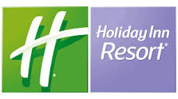

By 2023, with Holiday Inn Resort Bodrum, our guests will earn IHG points from their stay. They will be able to use their points in all over the world. Our Holiday Inn Resort brand, it will be the first in our country and the 45th IHG Resort concept hotel in the world. It will be first ultra all inclusive hotel among all IHG Group Hotels. Our guest will be able to use their points in all IHG group hotels as they wish their stays with 18 Hotel Brands, 6,164 Hotels and 911,627 rooms under the umbrella of IHG Hotels & Resort.

We share with you the hotel brands of which we are a part, which they can use in our country and in the world with the points they earn from their stay in our hotel, which is the first hotel of our country and the 45th hotel of Turkey. World.

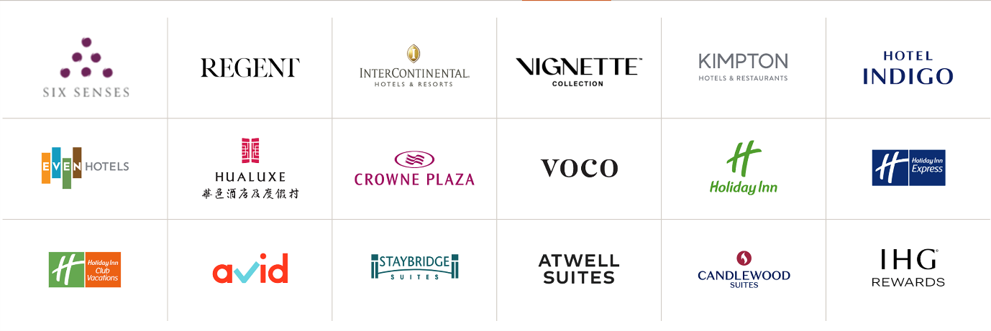

Kind regards,

Holiday Inn Resort Bodrum